# FINAL TESTING – Release 1 – 28th April

Story 1: Account registration

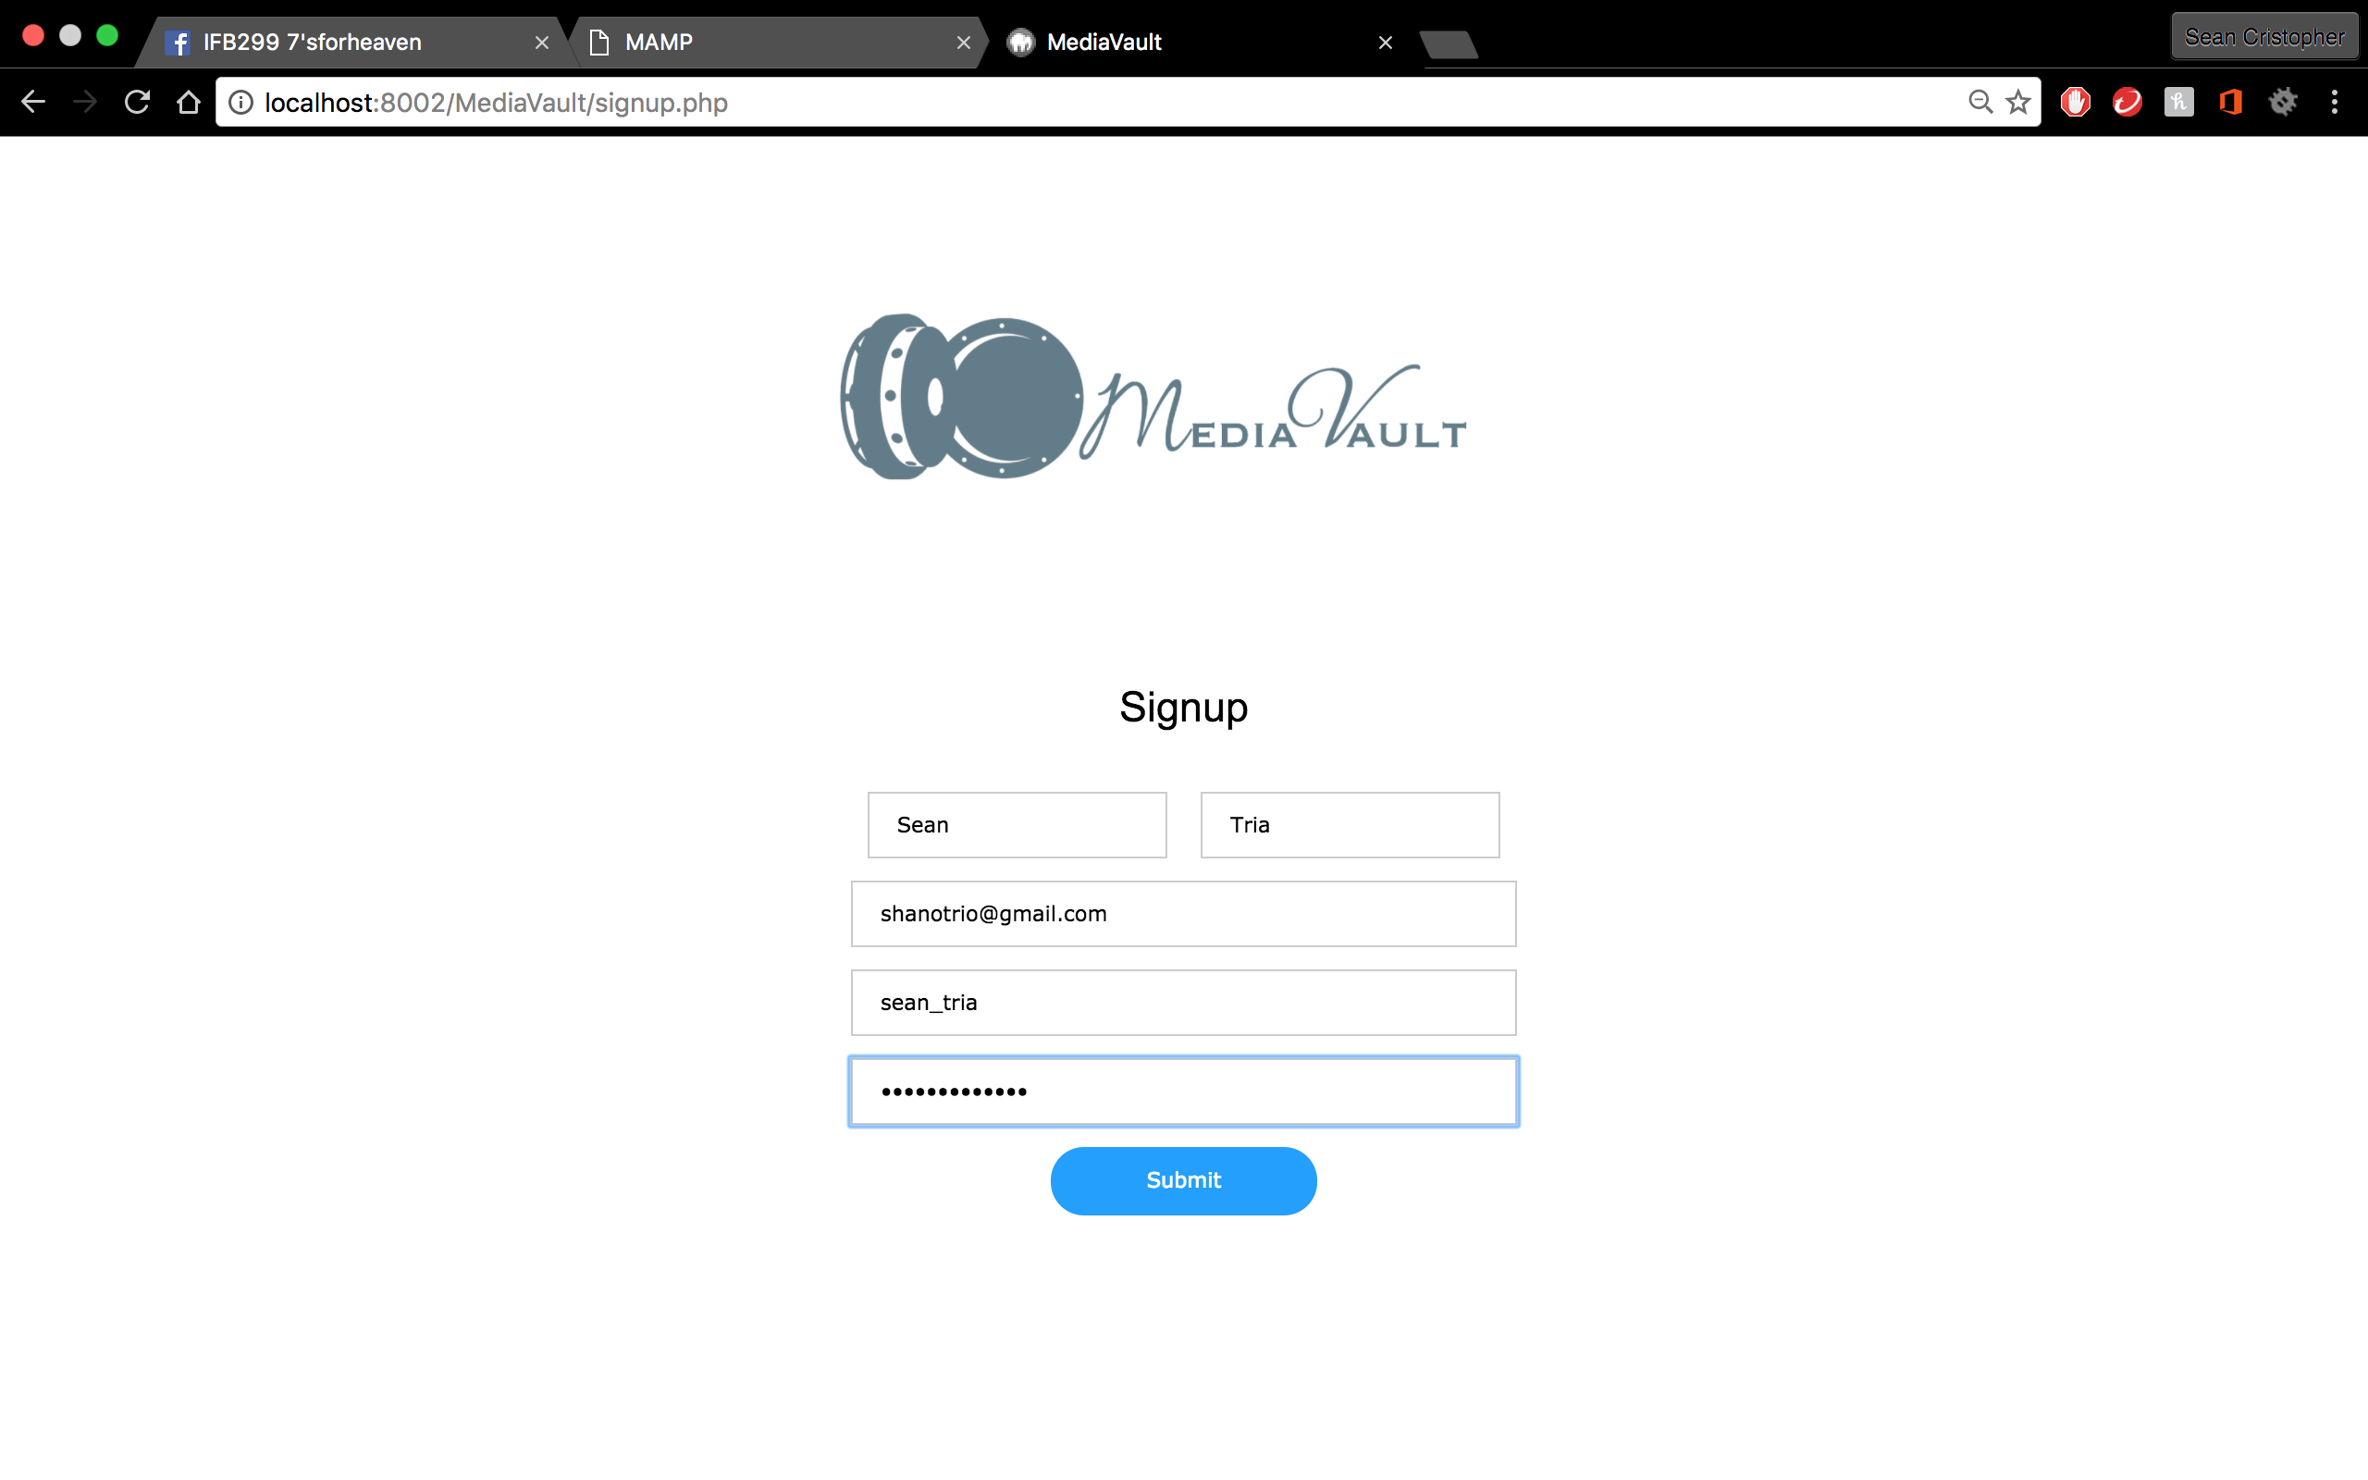

* Sign-up form is working
* User details is unique and cannot be duplicated
* User details is registered to SQL tables
* Doesn’t send email confirmation

Story 3: MediaVault Login

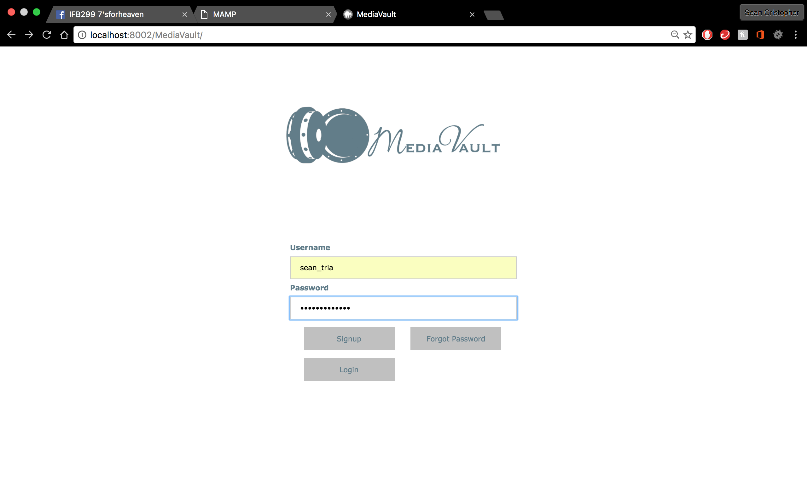 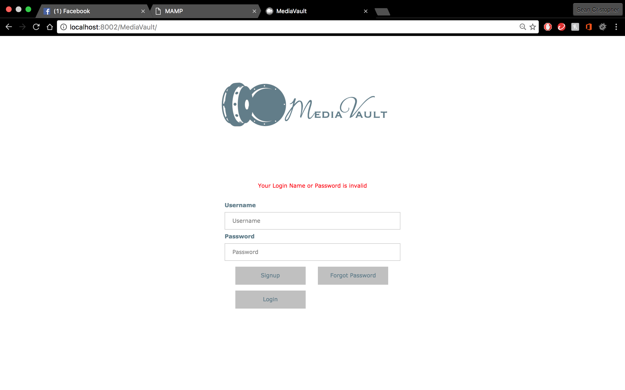

* Login information matches registered information in SQL tables and functions
* Error message pops up if information is incorrect

Story 4: View my Files

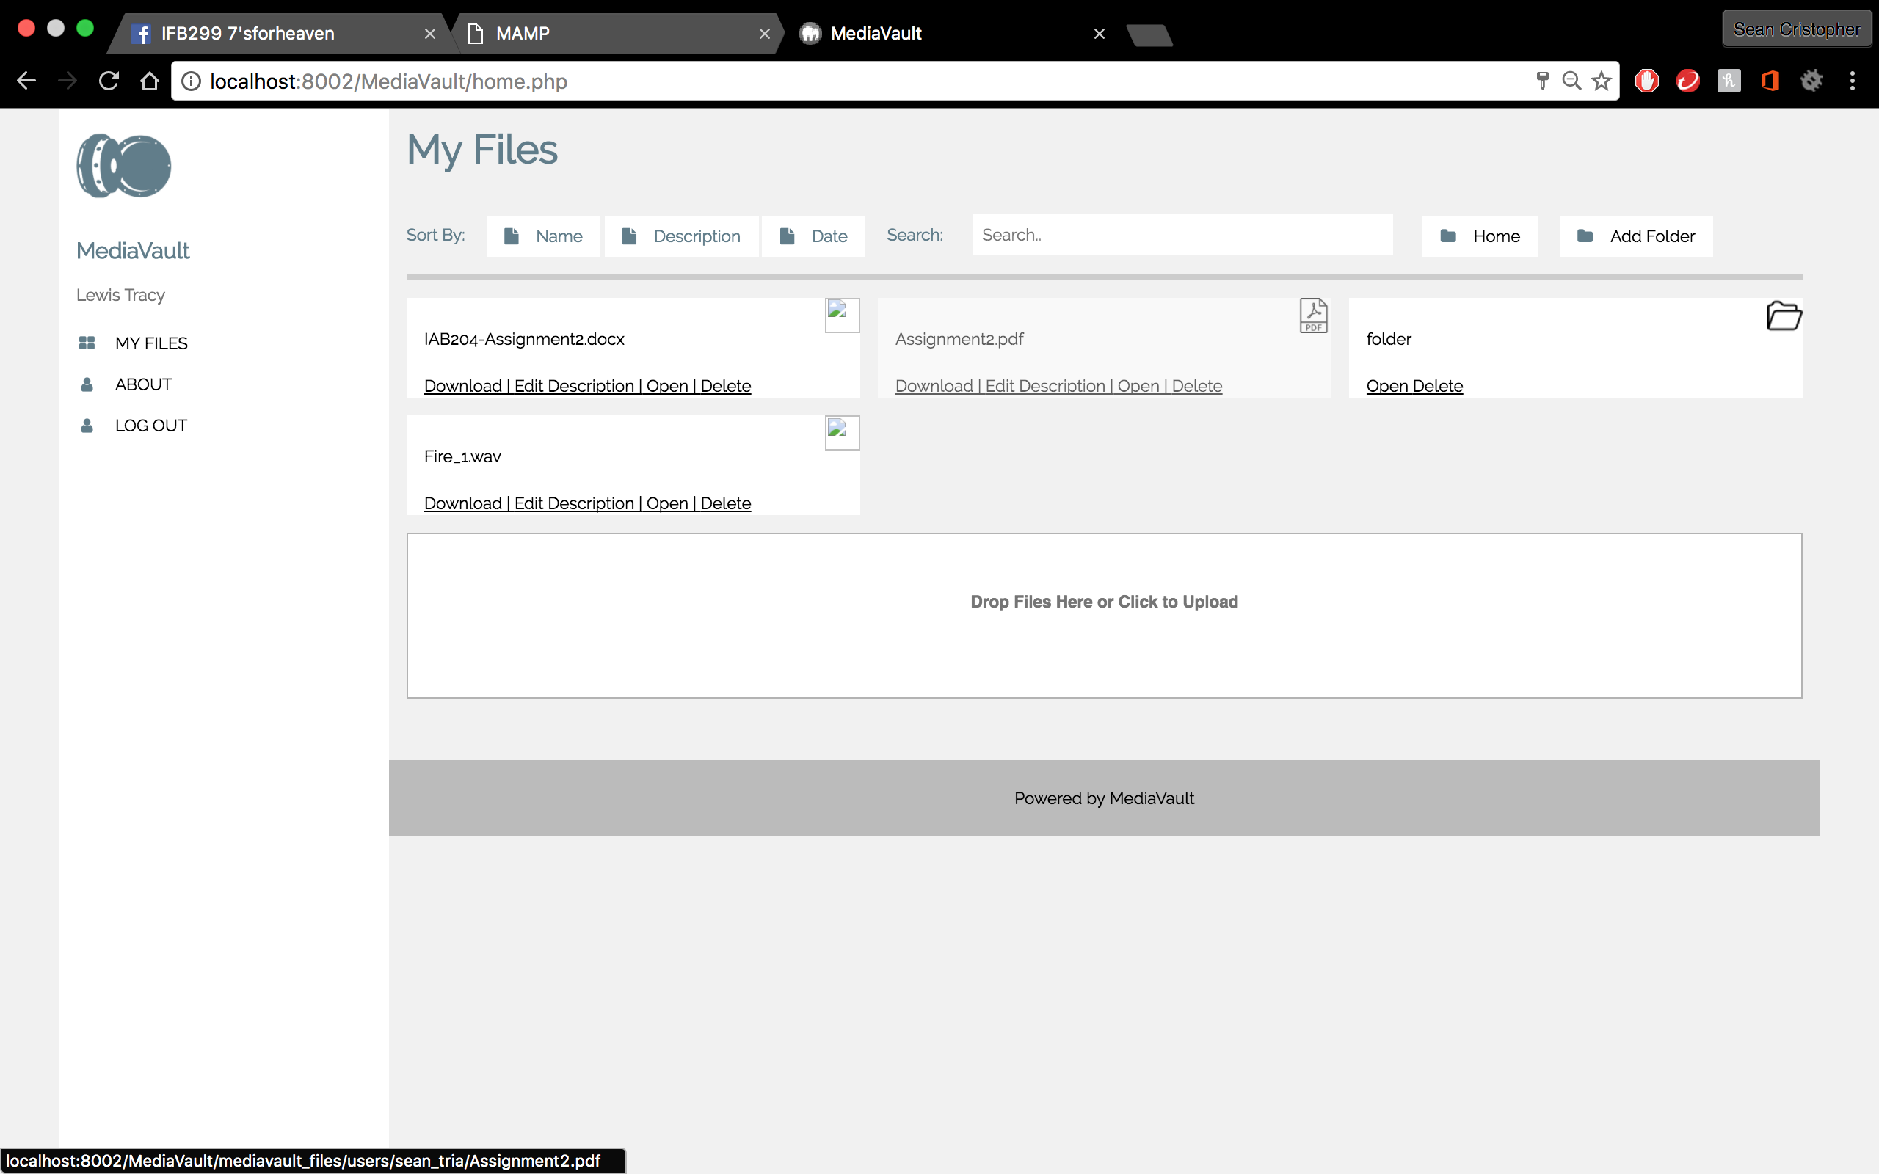

* Landing page successfully opens when login is successful
* Grid shows user’s files

Story 5: Download my File

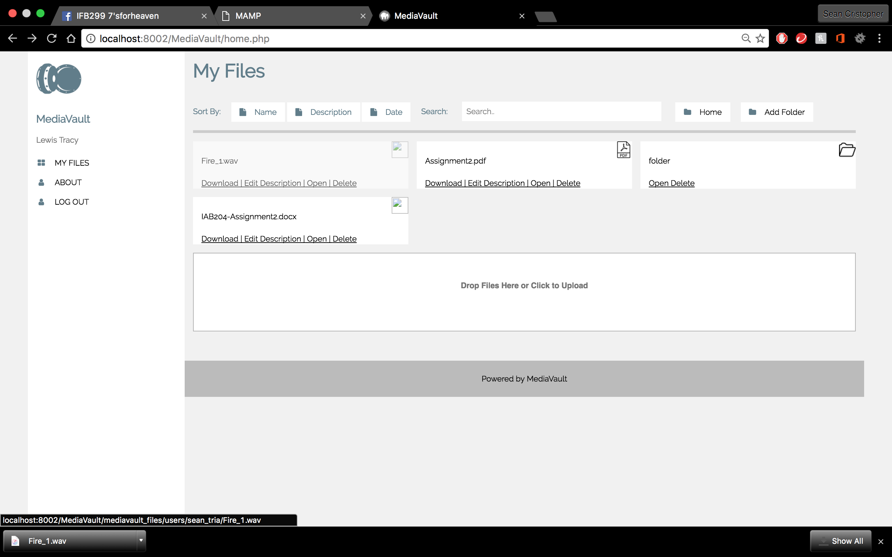

* Download button is independent for each file and functions when clicked
* Test shows the right file is downloaded

Story 6: Upload a file: file explorer

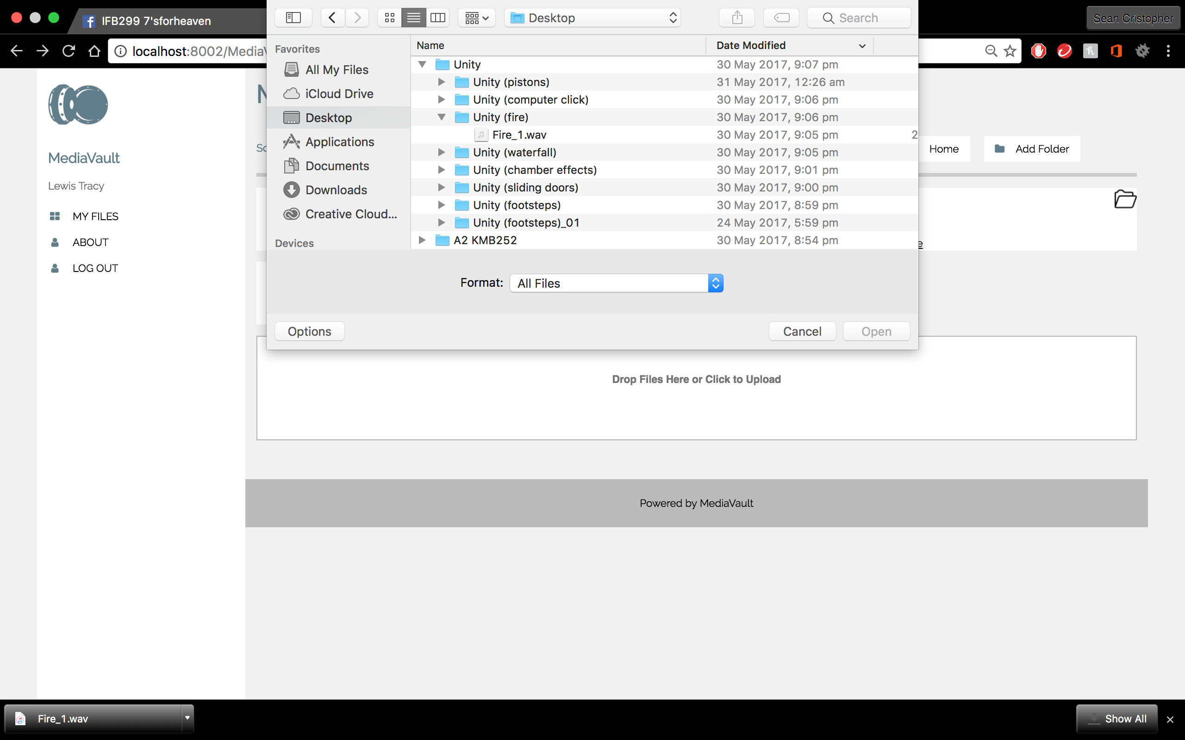 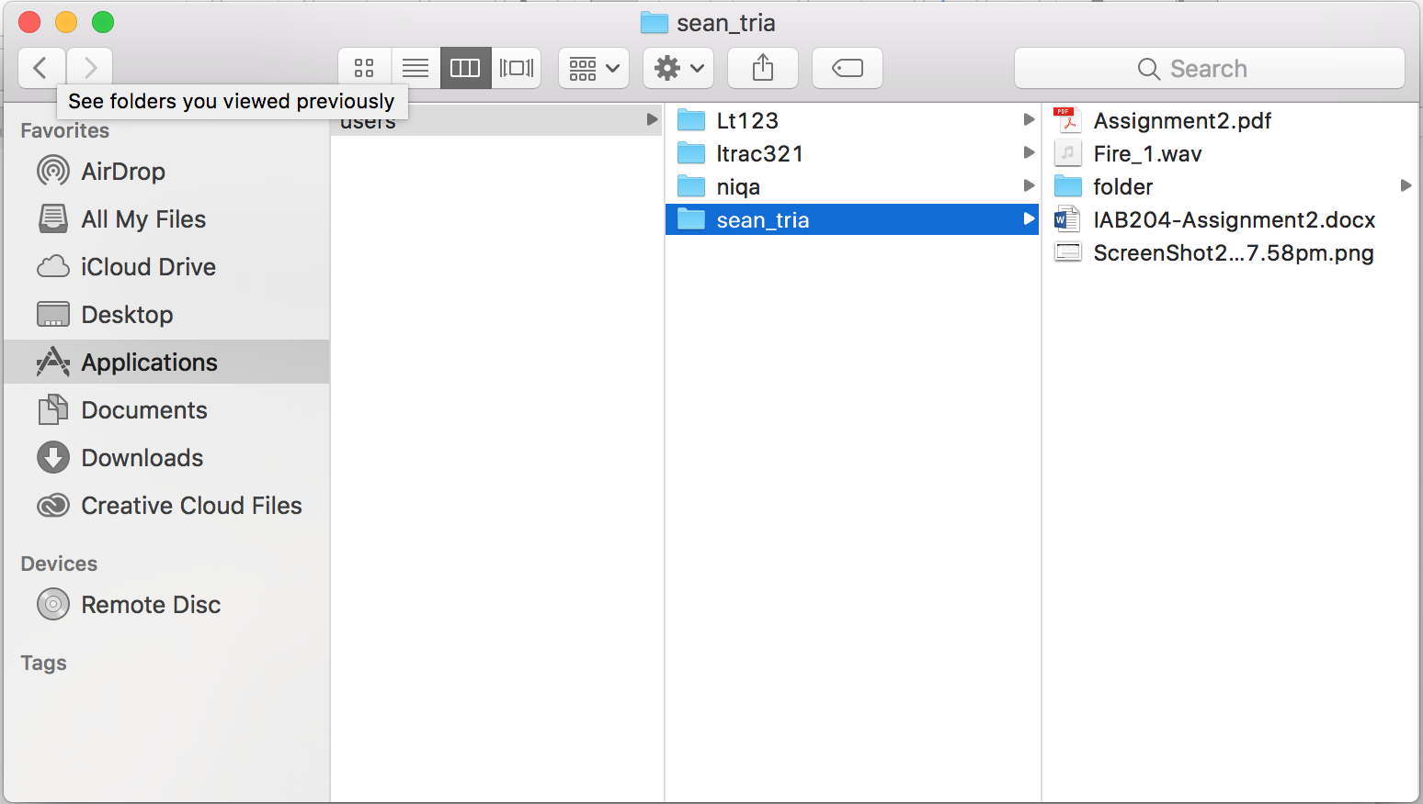

* Empty grid below functions as a button for file explorer for upload
* Test shows upload feature functions
* Test confirms the right file uploaded is on the grid

Story 6B: Upload a file: Drag and drop

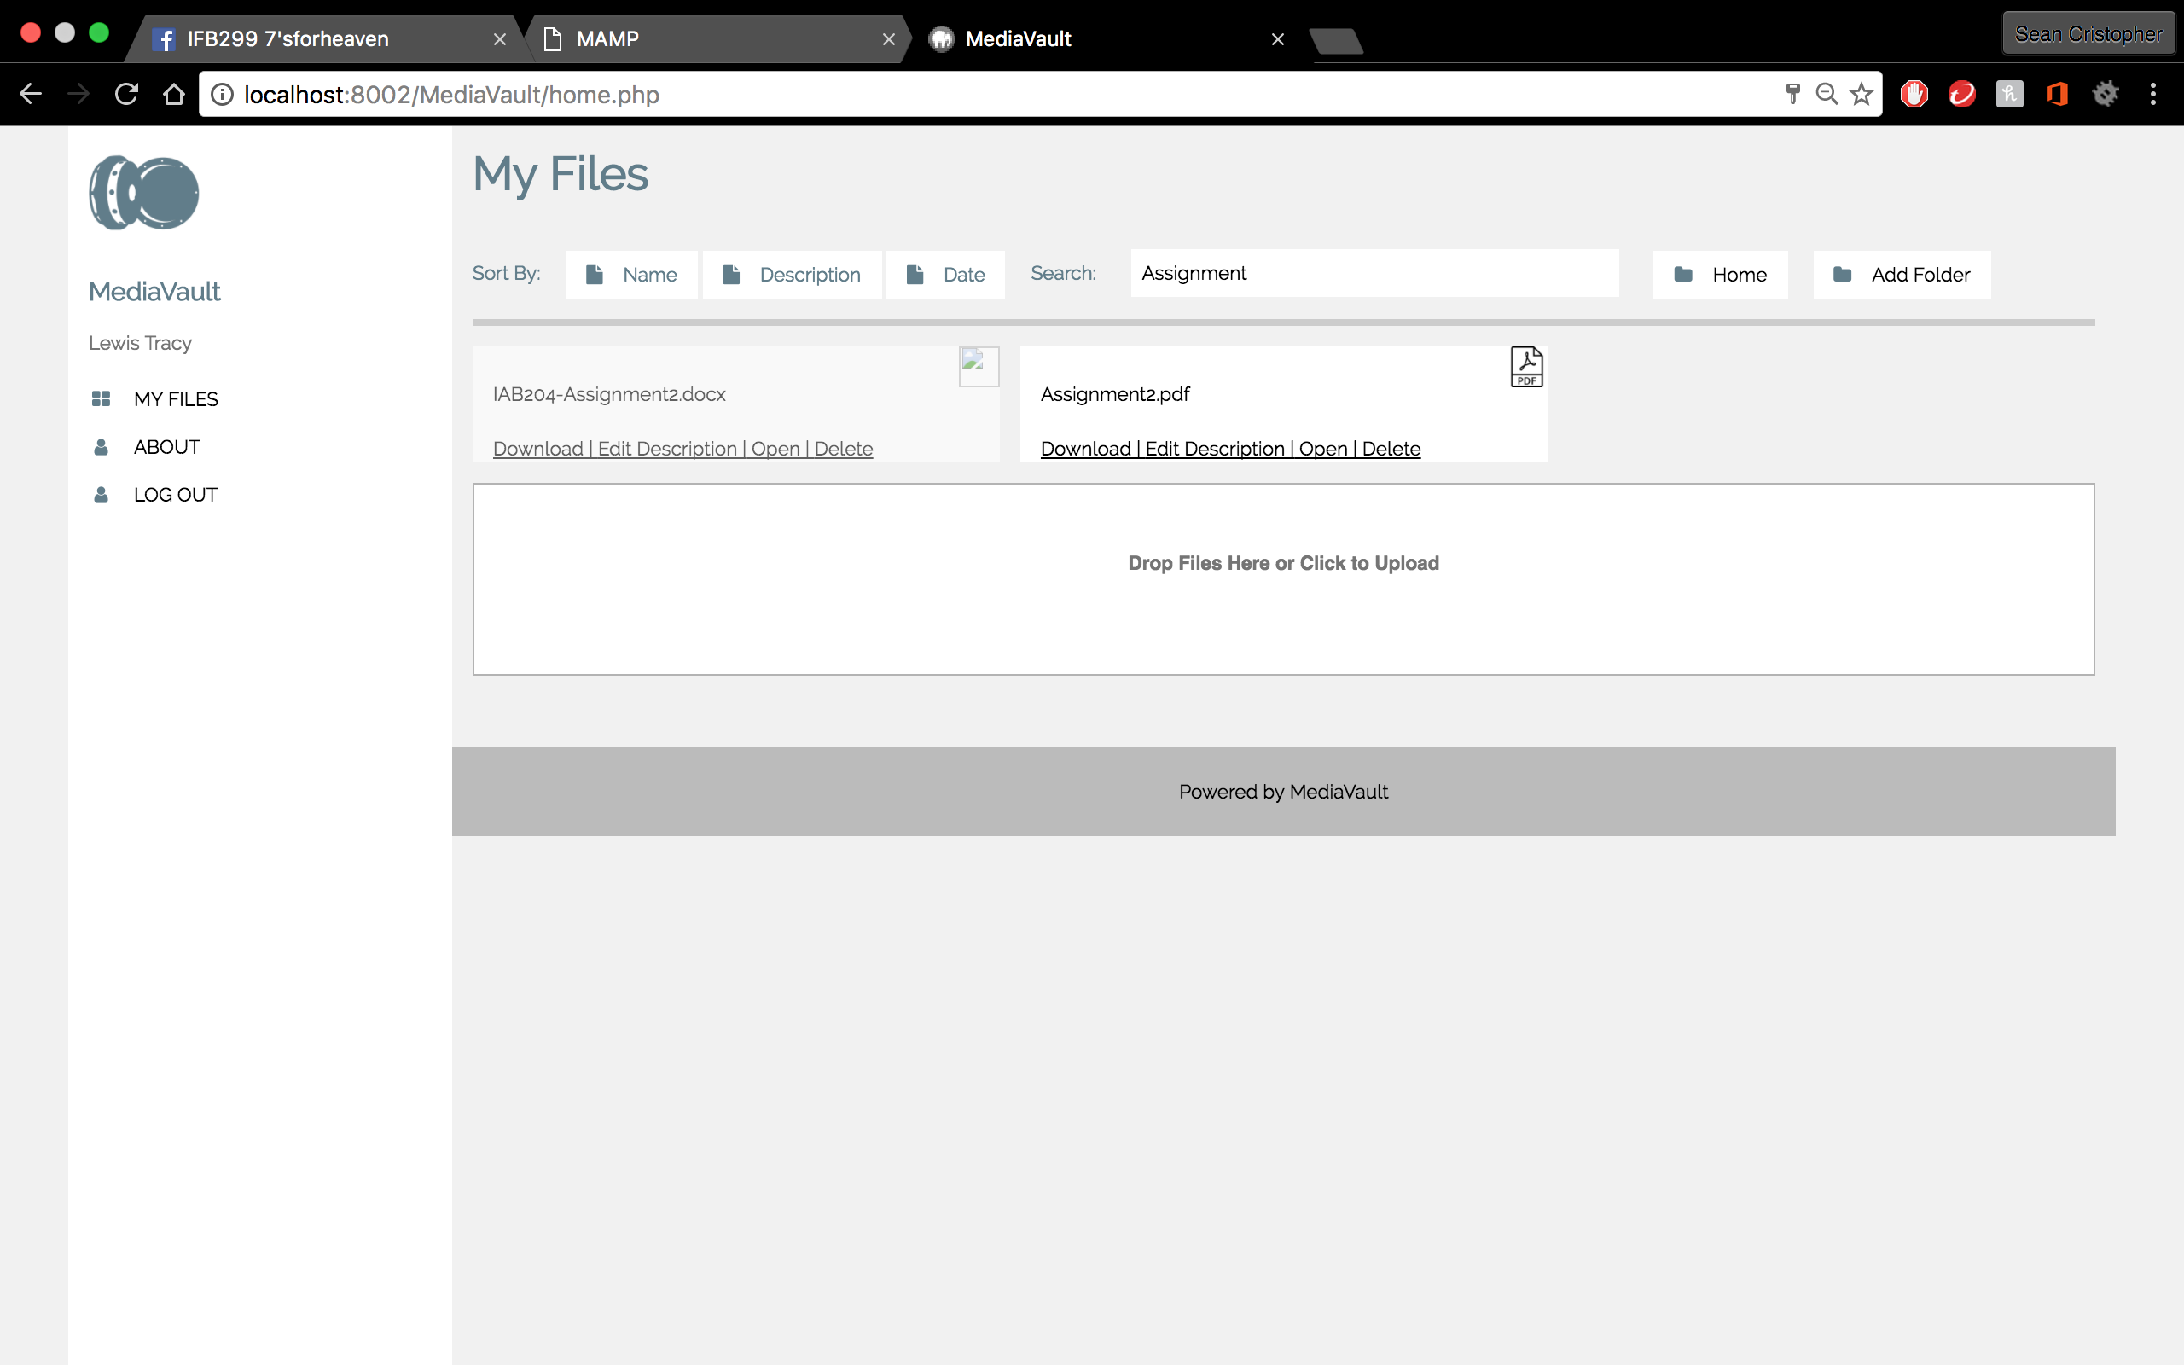 

* Empty grid below functions as a layout for drag and drop
* Files successfully uploads to file server just like file explorer

Story 18: View/Edit Account Details

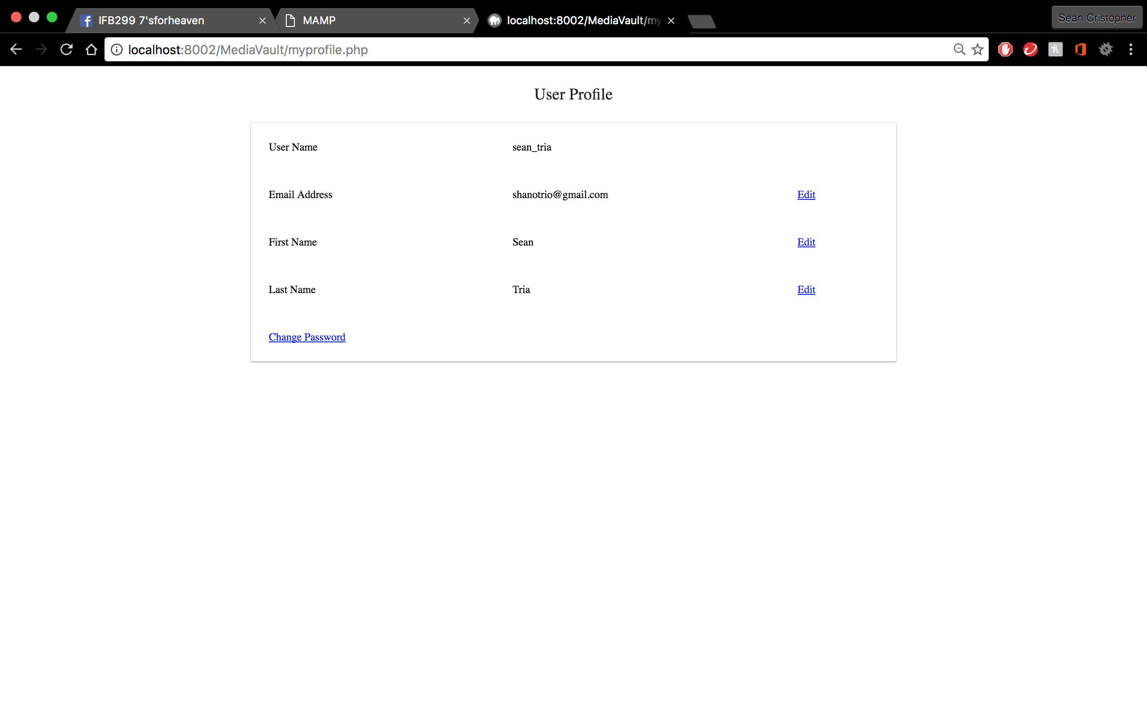

* View and edit account details functions
* Test shows edit dependencies

Story 19: Reset Forgotten Password

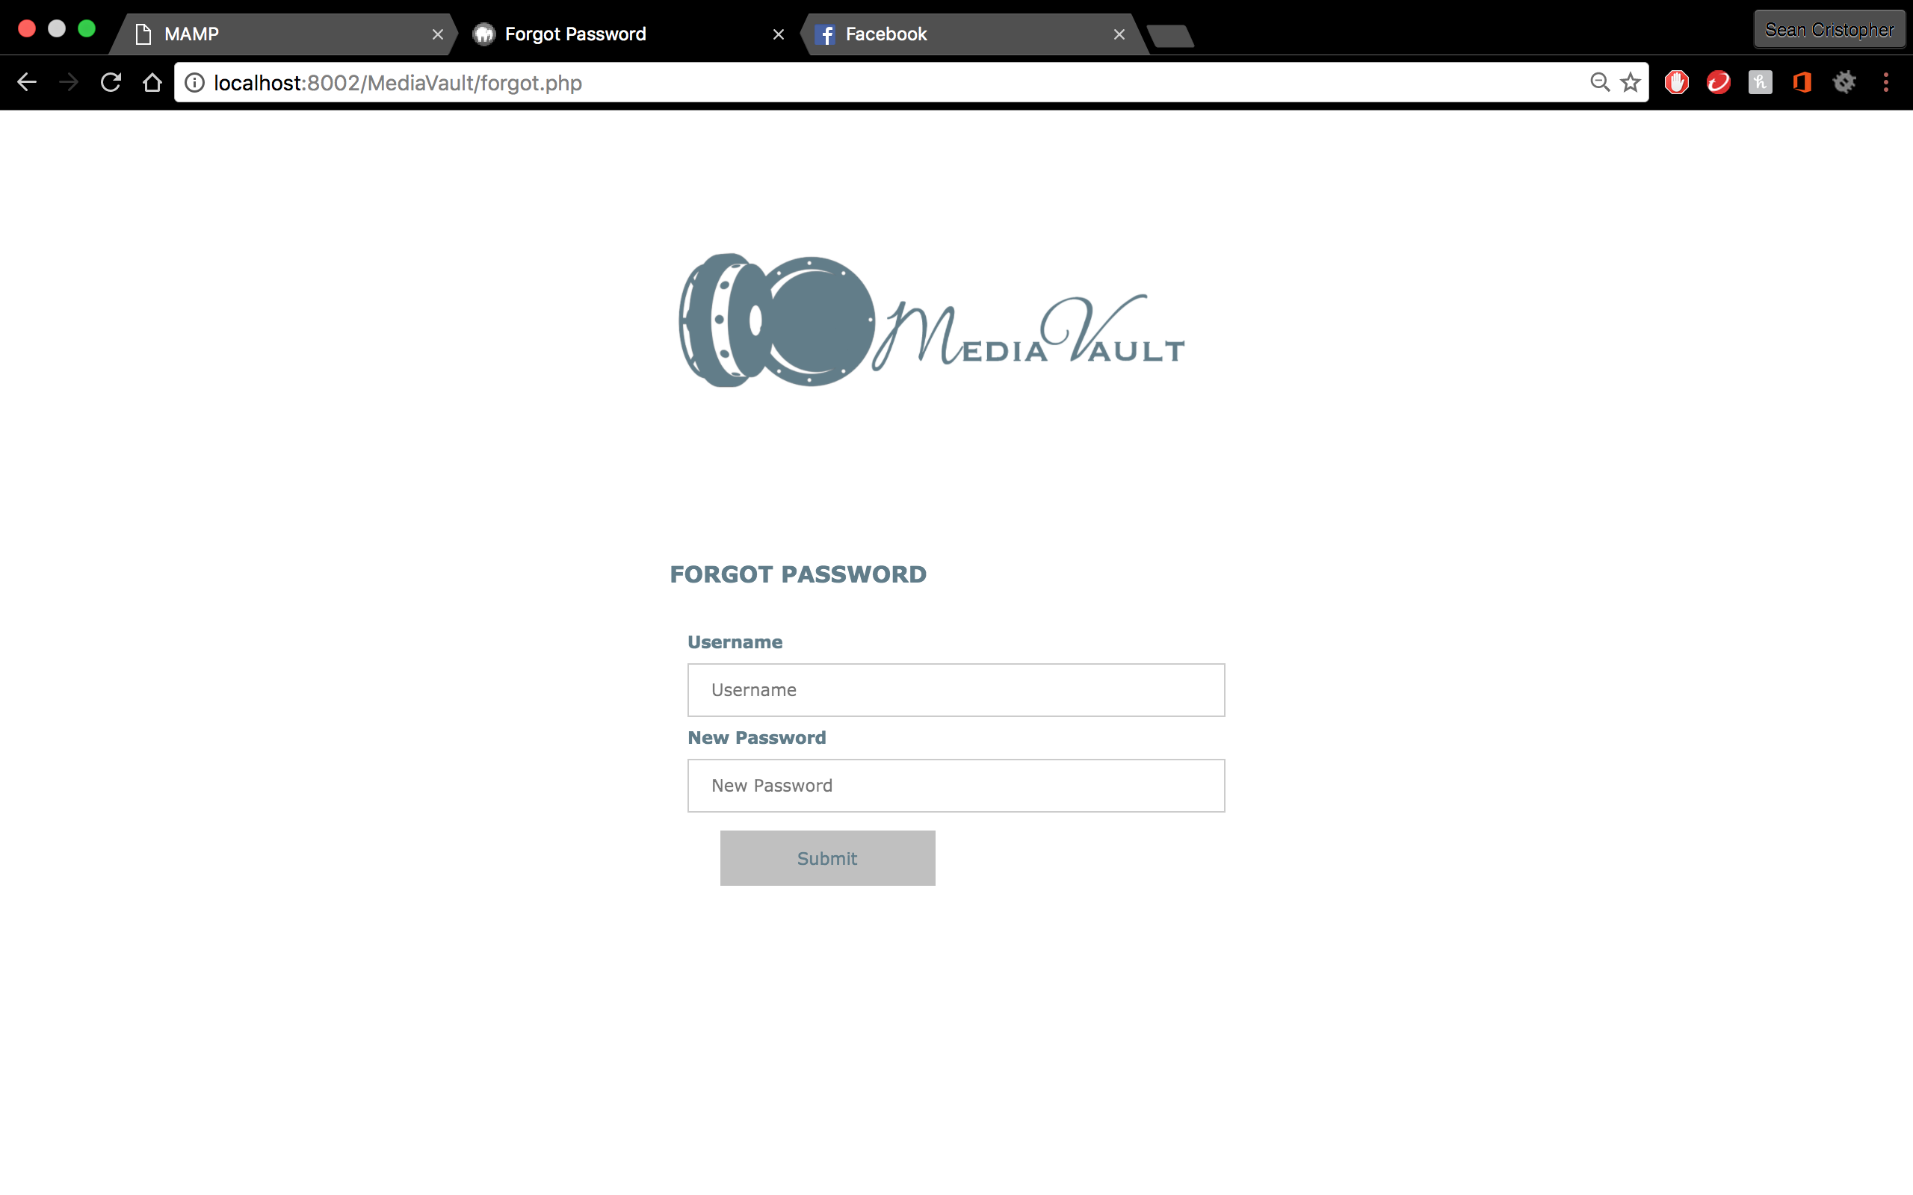

* Tests shows forgotten password functions
* If invalid username is used, correct error pops up
* Verifies authentication

Story 20: Log Out

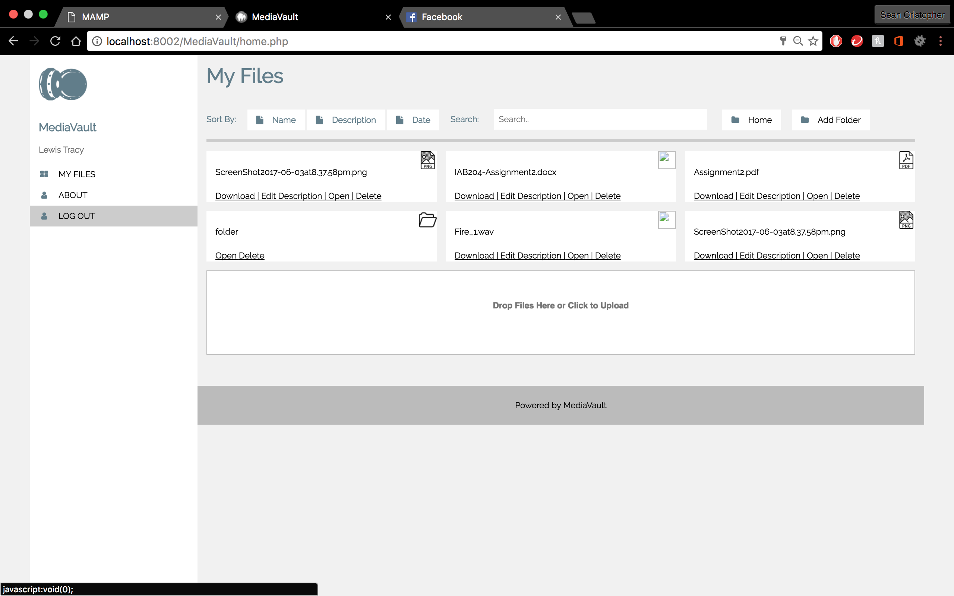

* Button is created for log out
* Tests shows logging out feature functions

Story 7: Add Folder

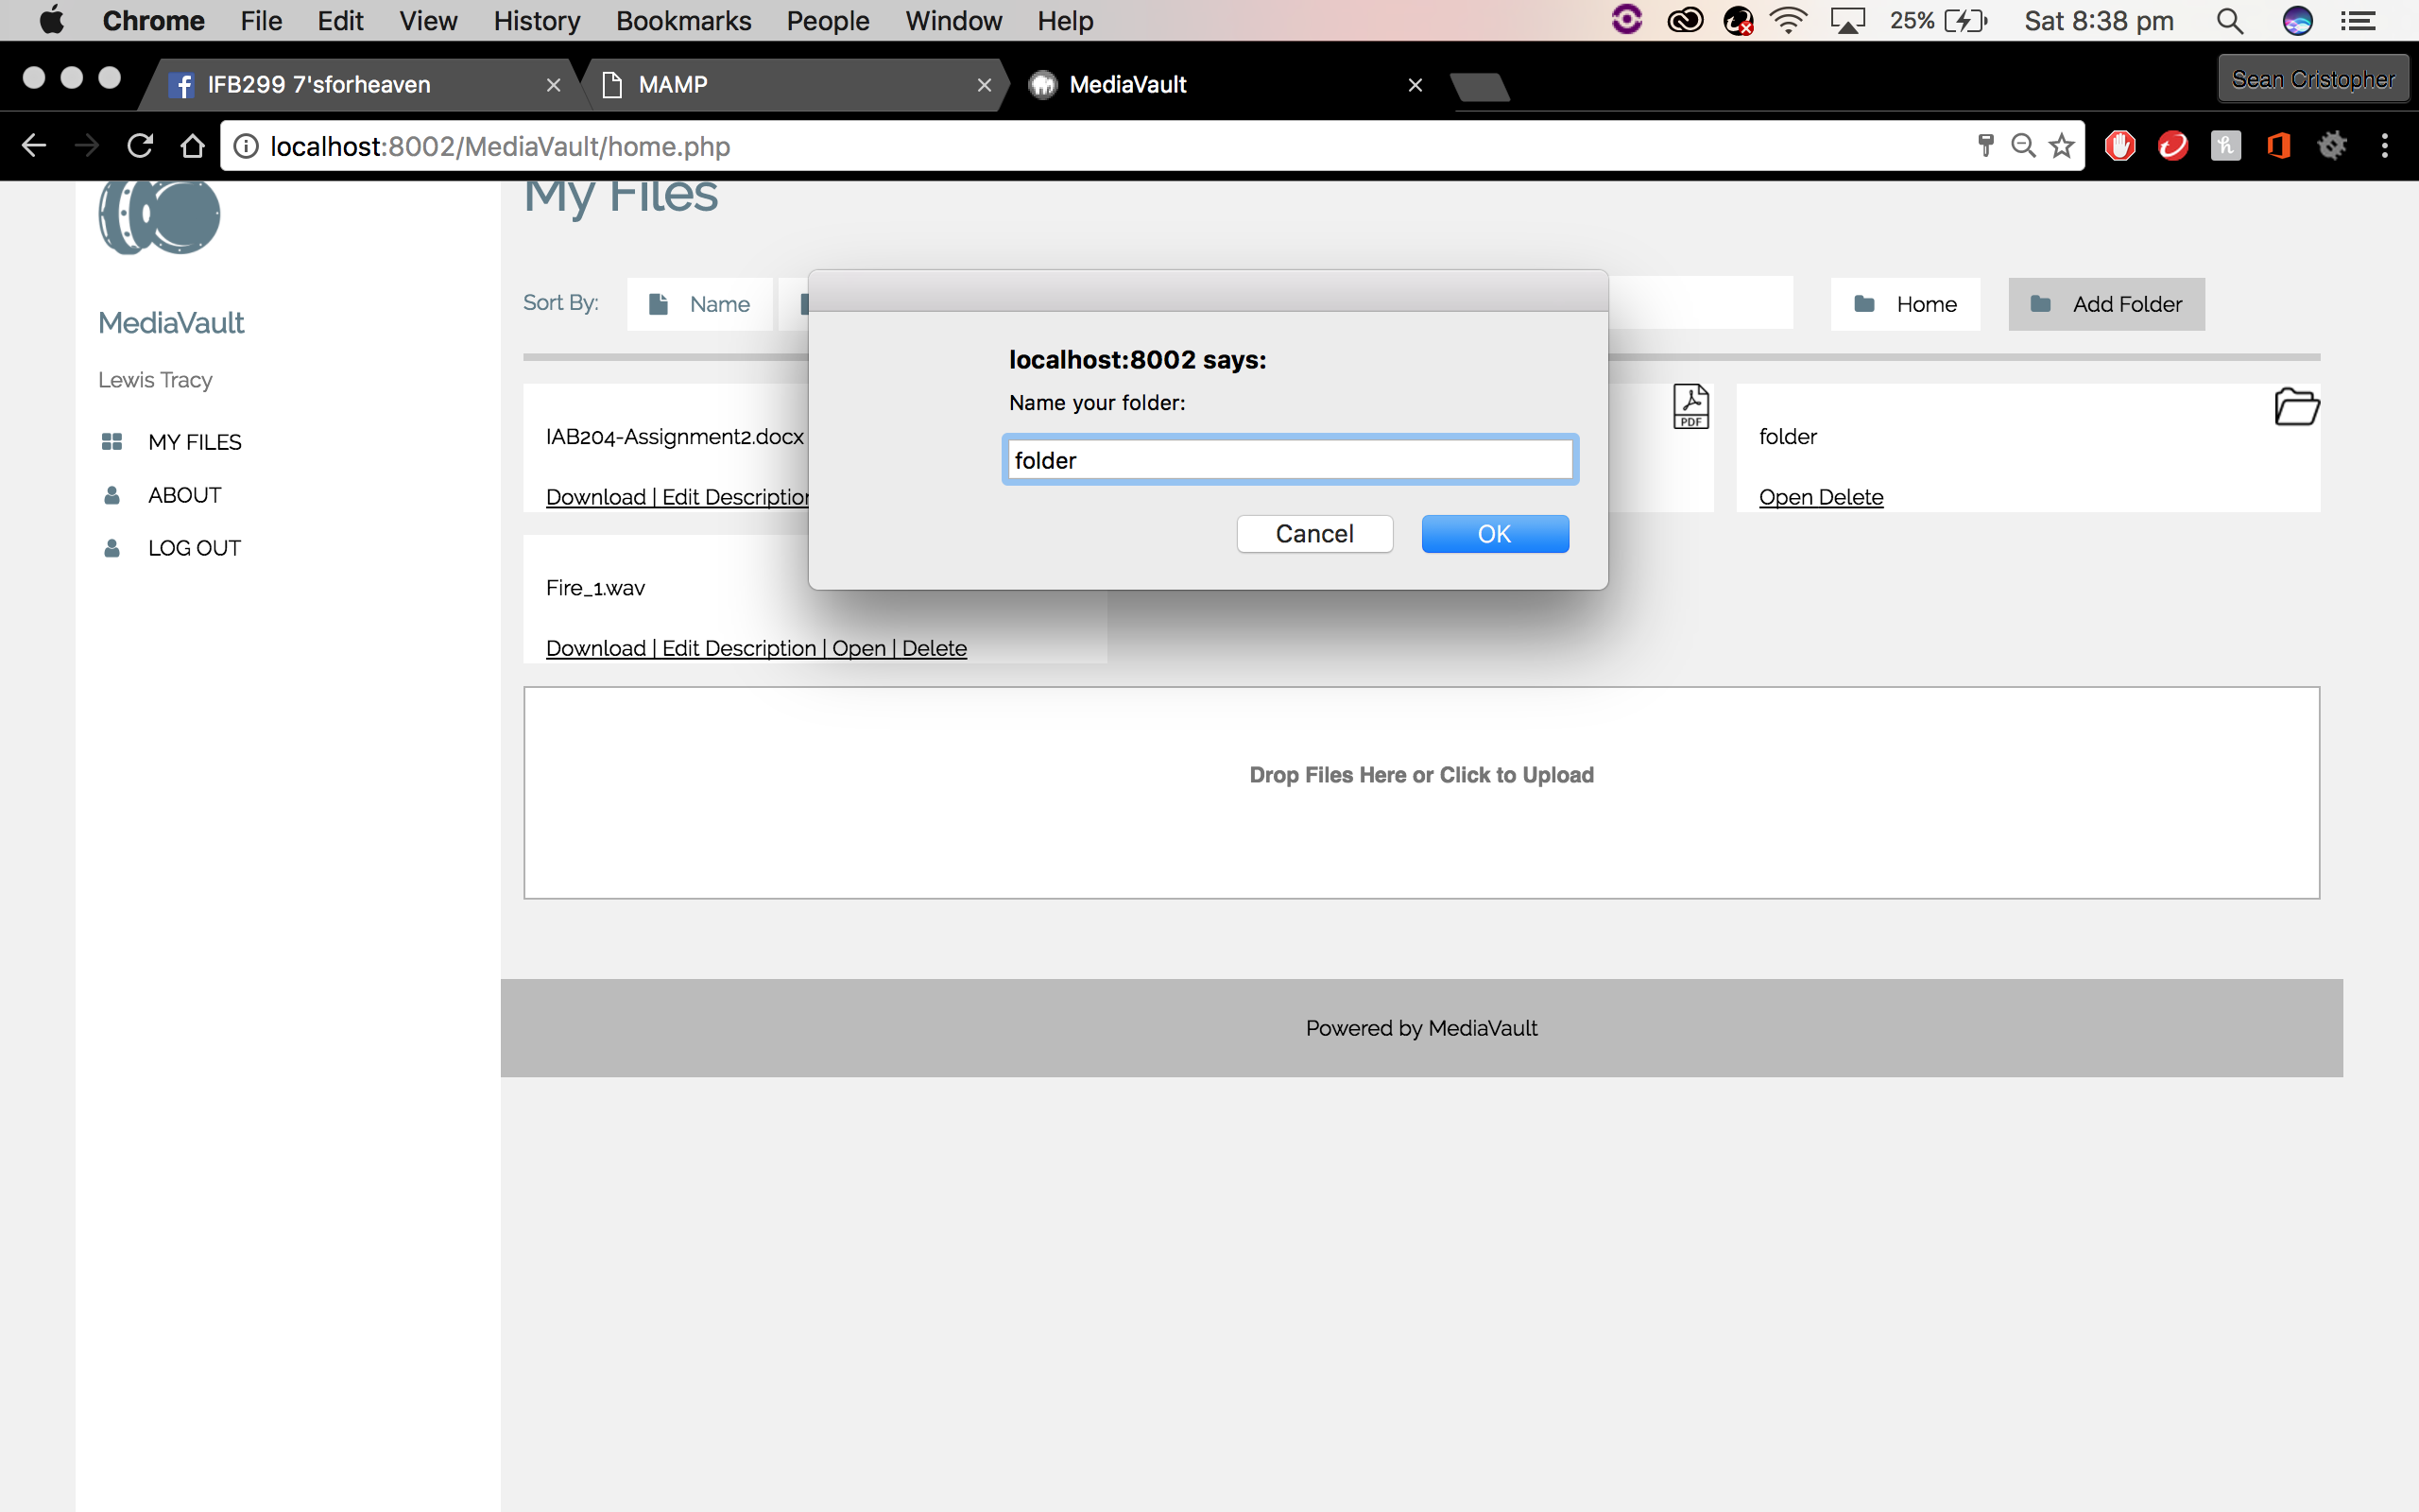 

* Button for adding folder is scripted
* Folder created is saved on the file server
* Folder created is added to the grid

Story 11: Delete File

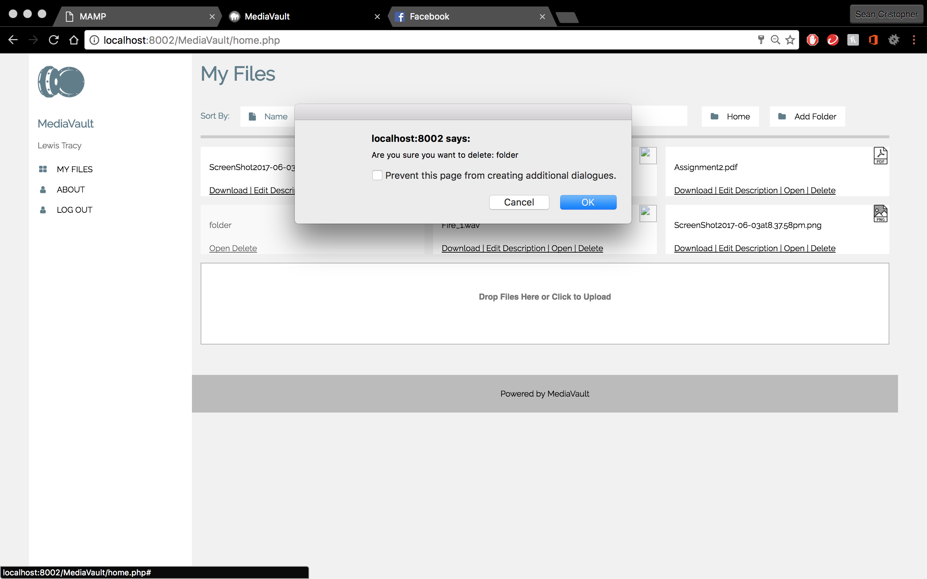

* Delete button is independent for each file/folder
* Pop-up message for user’s final decision on deleting file/folder/s
* File/folder deletes if user confirms
* The grid refreshes when deleted to upload the grid

Summary: Final testing of Release 1 is completed. Upload speed is fixed and is now instant. Automatic refresh is built in when uploading a file or creating a folder. Log out is now instant.